DIS-Eur-Vinca-Figurine-Female-13.5 cm

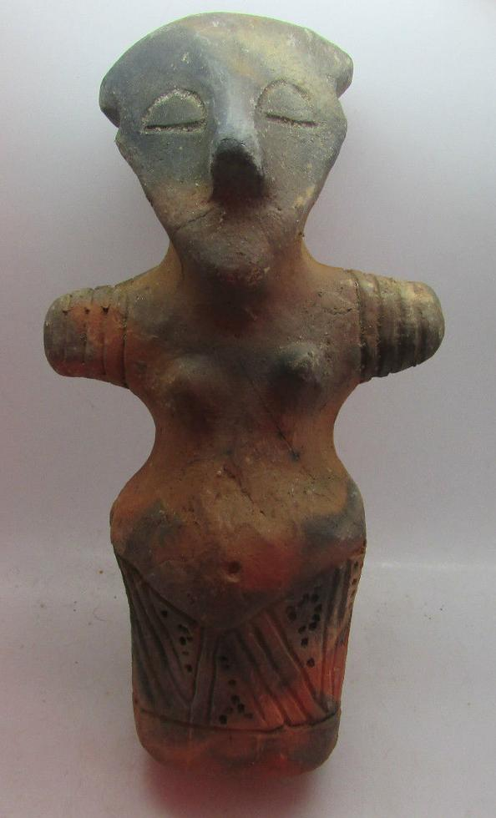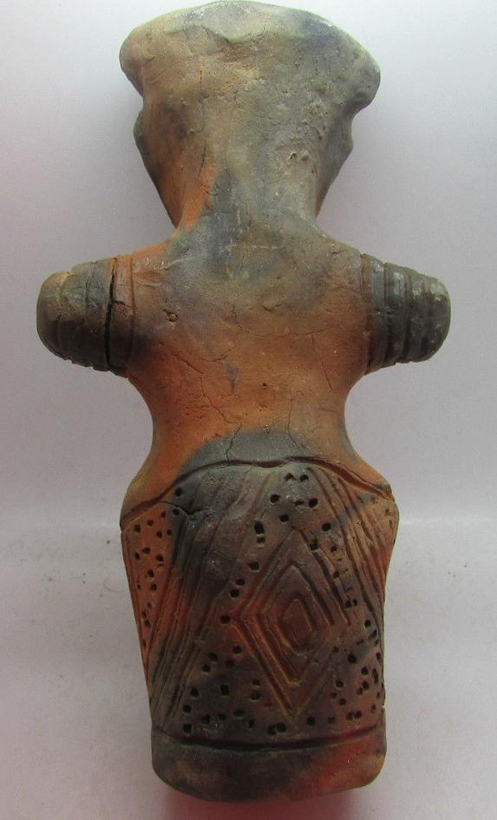

Formal Label: Vinca Neolithic ceramic female anthromorphic figurine, ca. 4500 BCE-13.5 cm

Accession Number: GN778.32.A5

Date or Time Horizon: ca. 4500 BCE

Geographical Area: Balkans

Cultural Affiliation: Vinca

Medium: Fired clay

Dimensions: H 13.5 cm

Weight:

Condition: Excellent

Provenance: Michael Davies 2 hanover court Didcot Oxfordshire ox11 8nu United Kingdom

**References:**

**Discussion: Intricate diamond and chevron pattern incised in skirt area**